The Plagiarism Spectrum

REMEMBER: If it is not your own words or your own idea…cite it!

If it is not common knowledge ( like George Washington’s birthday)….cite it!

**1. CLONE:**



**An act of submitting another person’s ideas and words, word-for-word, as one’s own.**

**2. CTRL-C:**



**A written piece that contains lots of text from a single source without alterations/changes.**

**3. REMIX:**

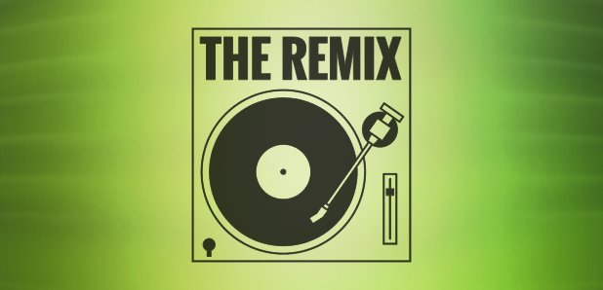

**The act of changing key words and phrases but retaining the essential content of the original source in a paper.**

**4. RE-TWEET:**



**A paper that includes proper citation, but relies too closely on the text’s original wording and/or structure.**

**5. MASHUP:**



**A paper that represents a mix of copied material from several different sources without proper citation.**

**6. NOT FOUND-404 ERROR:**

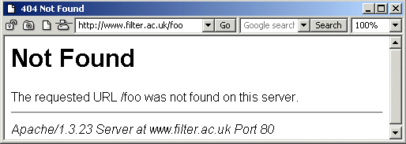

**A written piece that includes citations to non-existent or inaccurate information about sources**

**7. RECYCLE:**



**The act of re-using part or all of one’s own (or a friend’s) past paper; To self-plagiarize.**

D. Rosenblum, adapted from Turnitin.com

"White Papers." *Turnitin -*. Turnitin.com, 2014. Web.